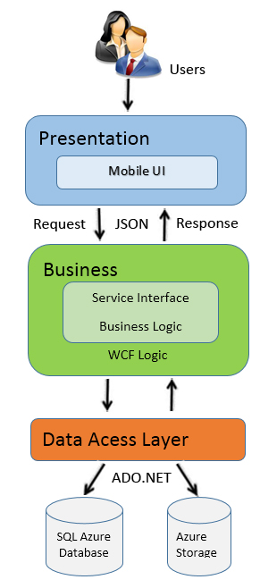

The application will use the Three-Tier architectural model as the main architecture. It makes use of the Internet and JSON protocol to deliver its services to the users.

The main entities of the above diagram will be described as following:

**Presentation Layer**: This is a layer is used to communicate with the user by using Android UI , the main task is that display data and receive data from the users. Simply, this is the interface of the application to communicate with people using the app, receives requests then forwards to the Business Logic. After processing is complete, the application to recognize response from businiess Logic and displayed to the user that the results of the process. This layer is also responsible for checking the data entered by the user, to control the operation of the user, help user to use the application. This layer contains 4 functions: User, Project management, Messages, Notification functions.

**Business Layer**: Main task is that provides the functionality of the application. This layer contains all the main function of the app, the input and output handler, the data manipulation functions to the request from the Presentation layer, after finishing operations resulting from the Data Tier and pay Presentation on the floor to show the results to the user. This layer uses WCF Service that contains: Service Interface ( Message Manager, Notification, Project management, User management interfaces) and Business Logic ( Message Manager. Notification, Project management, User management bussiness logics ).

**Data Access Layer**: This is data storage, allowing layers Business Logic can search, extract, update…data then returns results for Business Layer . It contains SQL Azure Database and Azure Storage are the database storage where all the data for application is stored.